**FRONT END PROJECT**

By: Aakash Jha

Enrollment Number: 2110990005

Class: G5

Department: CSE, 3rd Year

Instructor: Mr. Lavish Arora

Report Contents:

* Introduction
* Website Sections
* Technology Used
* About Us
* Challenges and Learning
* Conclusion

Slay In Drip - Your Fashion and Style Destination

Introduction:

Welcome to "Slay In Drip," your one-stop destination for a seamless and stylish online shopping experience. I, as the creator, have meticulously crafted this platform with cutting-edge technology to bring you a world of fashion at your fingertips. With an enticing combination of HTML, CSS, and JavaScript, I've harnessed the power of these web technologies to offer you a dynamic and user-friendly e-commerce experience. At "Slay In Drip," I take pride in my LocalStorage implementation, enabling you to manage your shopping cart effortlessly. I also offer a unique and personalised touch with global theme configuration, allowing you to set the perfect mood for your shopping journey. Whether you're a fashion enthusiast or a casual shopper, my website ensures that your experience is nothing short of exceptional. Dive into my fashion wonderland, and let "Slay In Drip" redefine your online shopping adventures.

Website Sections:

Website has various sections that make it easy to shop for fashion and style products. You'll find the Home Page, About Us Page, Contact Page, Fashion Catalog, Individual Product Pages, Cart Management, Secure Payment, User Account Management, Support Ticket System and Terms and Conditions Page. Each section is designed to give you a great shopping experience.

Technology Used:

Website Uses HTML, CSS, and JavaScript. These are the tools that help the website look good, work well, and let you interact with it easily.

Challenges and Learning:

During this project, I focused on the fundamental aspects of JavaScript, CSS, and HTML implementation. I utilised various elements of these technologies, such as HTML Forms, HTML5, CSS Selectors, CSS Inheritance, DOM Manipulation, Event handling, localStorage, querySelectors, and more.

One Challenge was there when I was trying to make the site dynamic for loading different products' data. Later I decided to use URL Search Params for this, which worked fine.

Conclusion:

Slay In Drip is here to offer you top-notch fashion and style products. We learned a lot while building the site, and we're dedicated to making your shopping experience the best it can be.

Thank you for choosing Slay In Drip for your fashion and style needs. We're committed to serving you with excellence and dedication. Our website is designed to make your shopping experience smooth and enjoyable.

ScreenShots

**Login Page**



**Signup Page**



**Home Page**

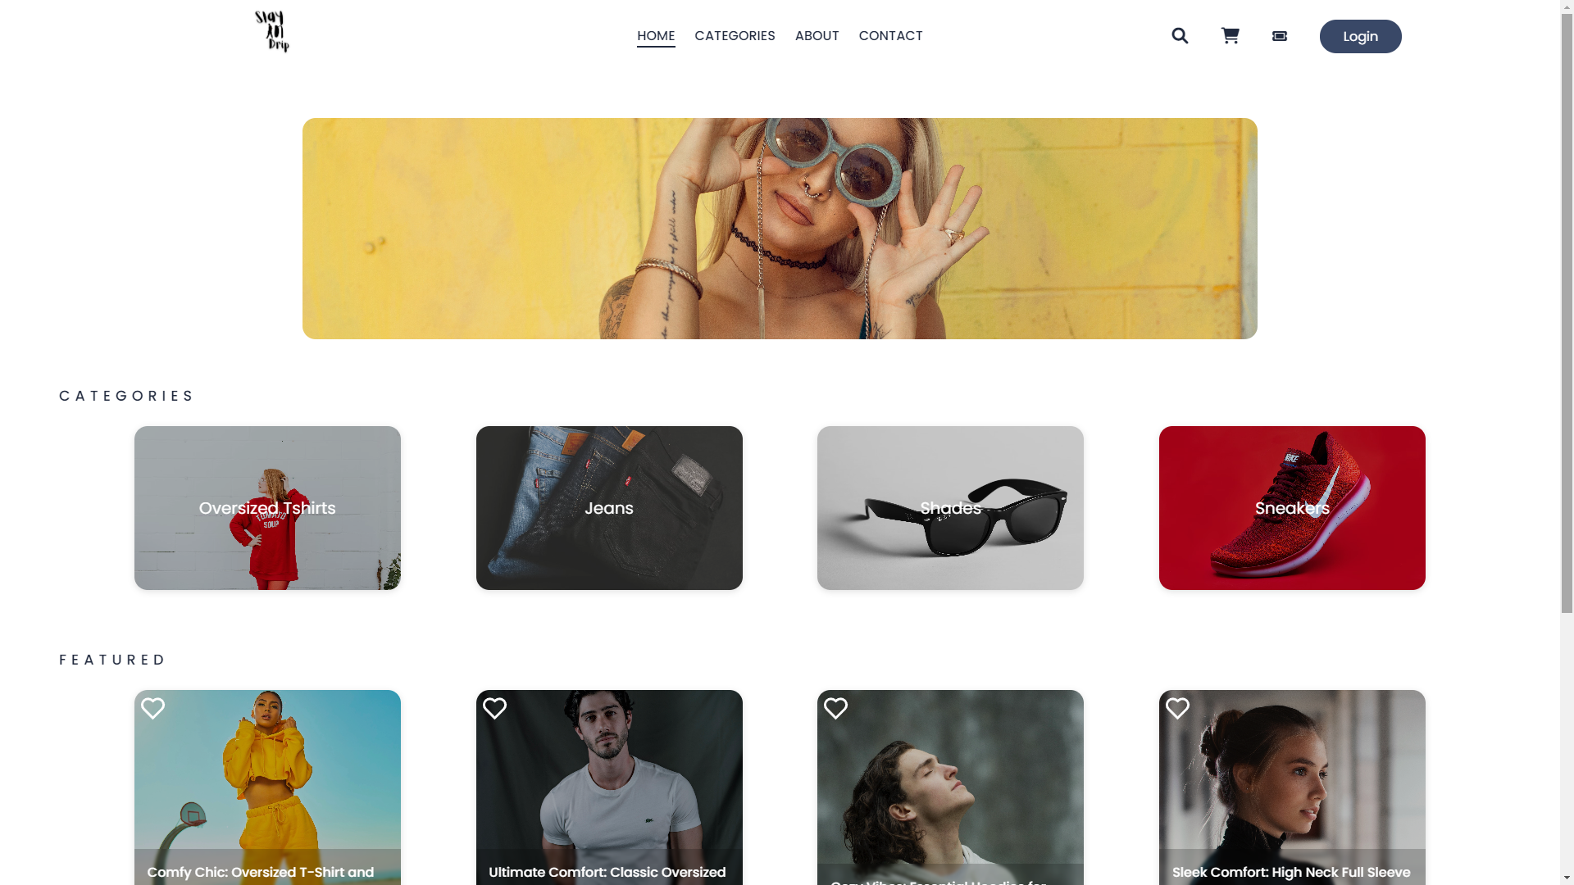

**Categories Page  
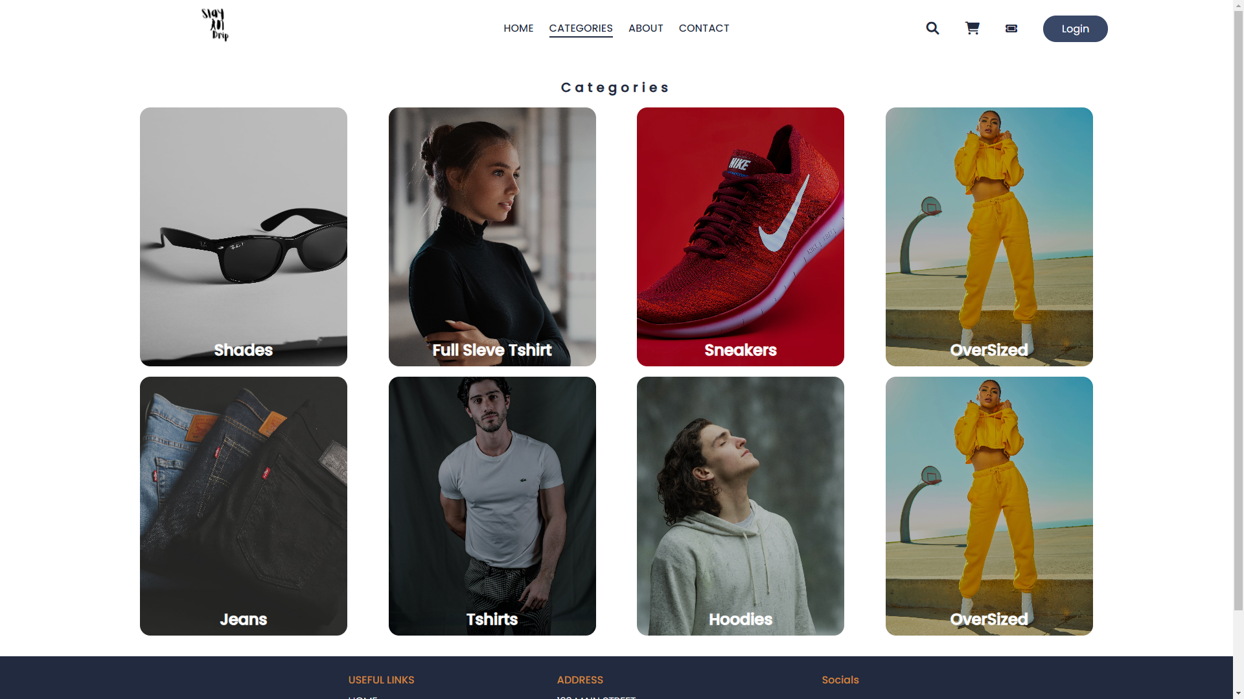**

**Search Page**

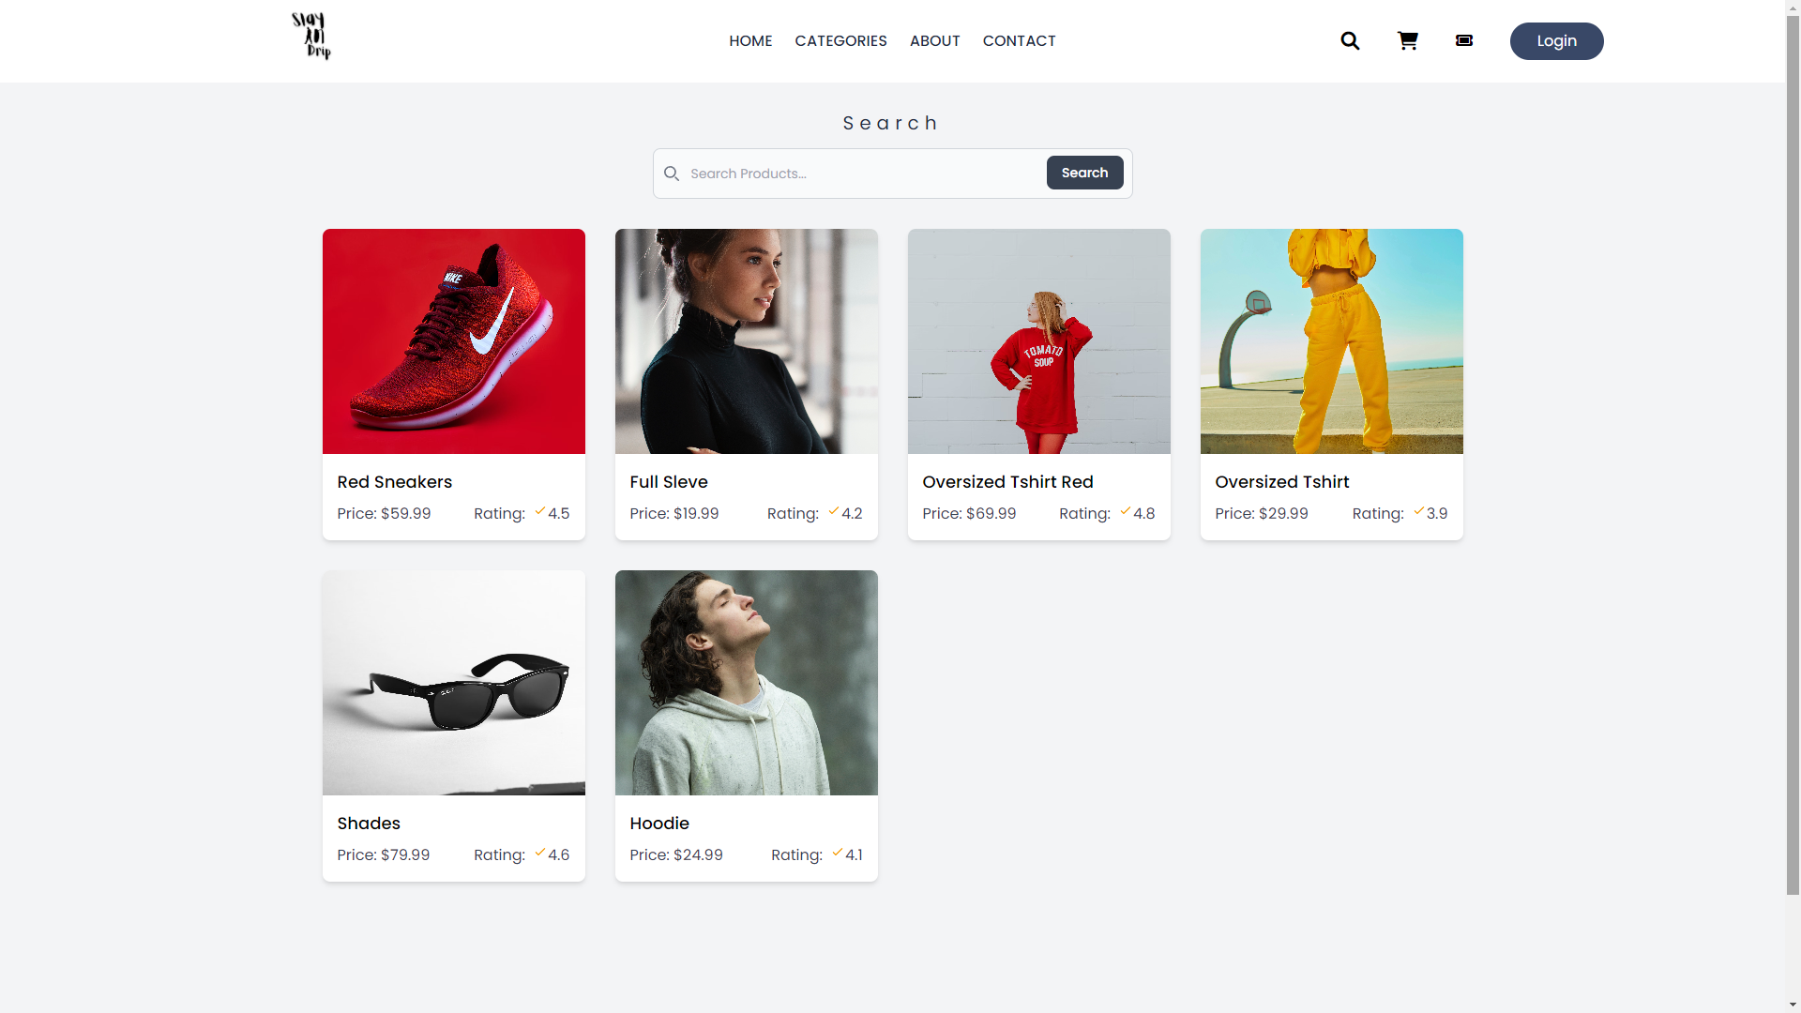

**Product Page**

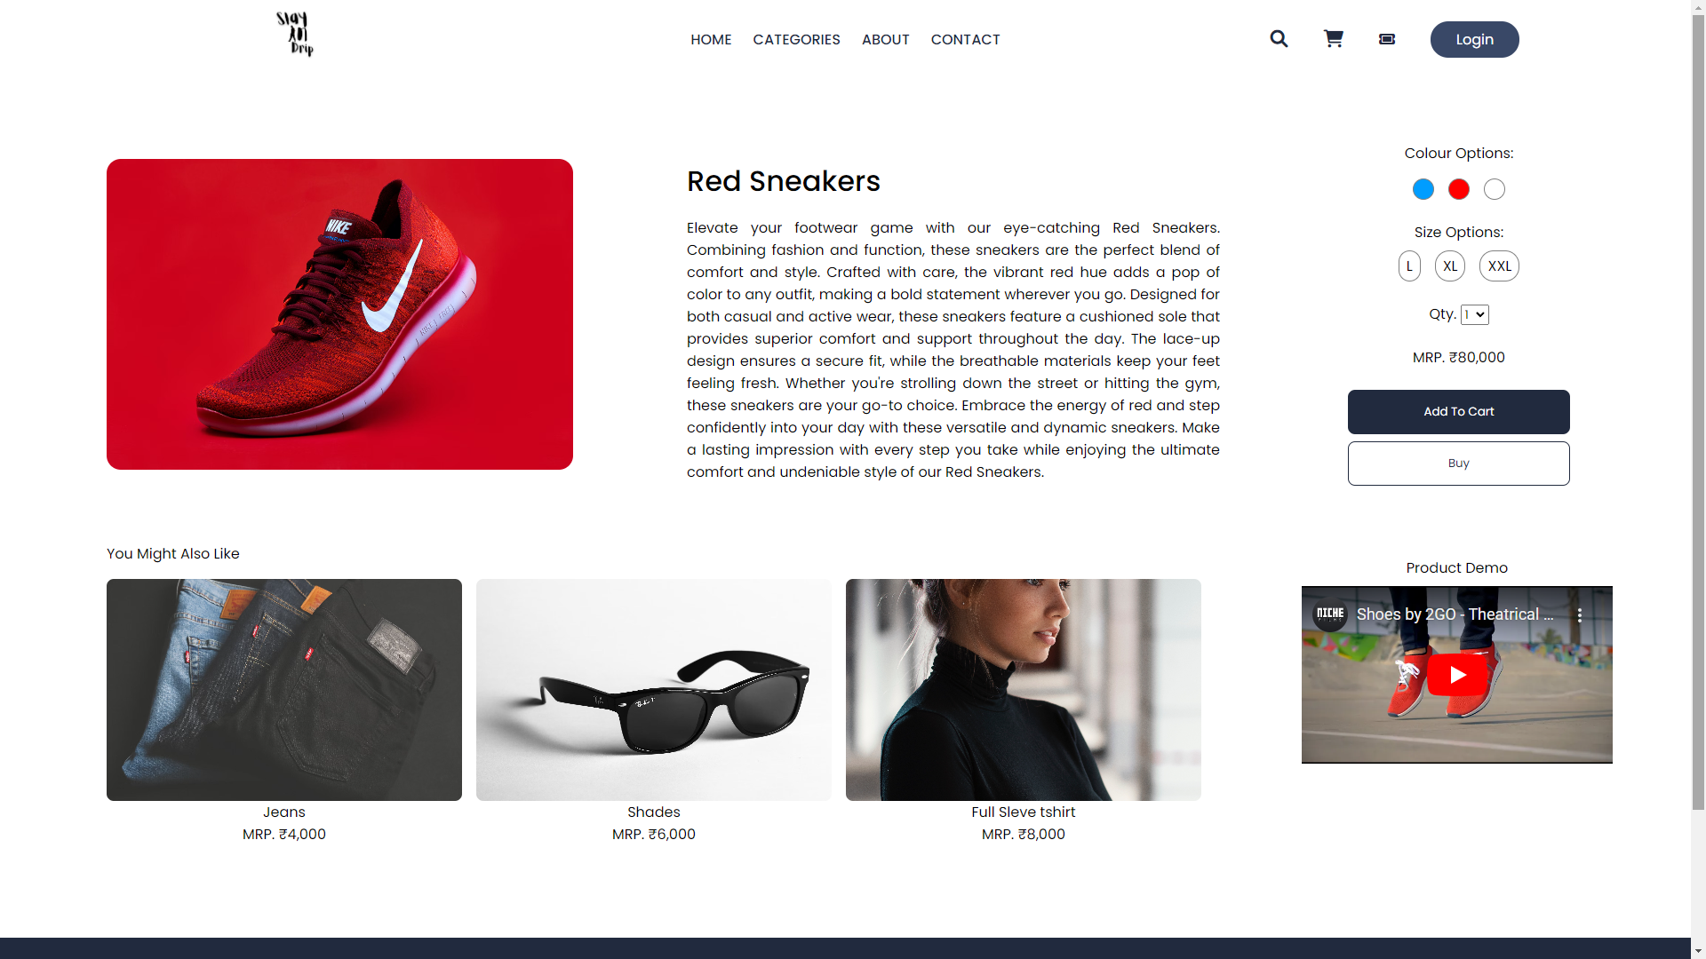

**Cart Page**

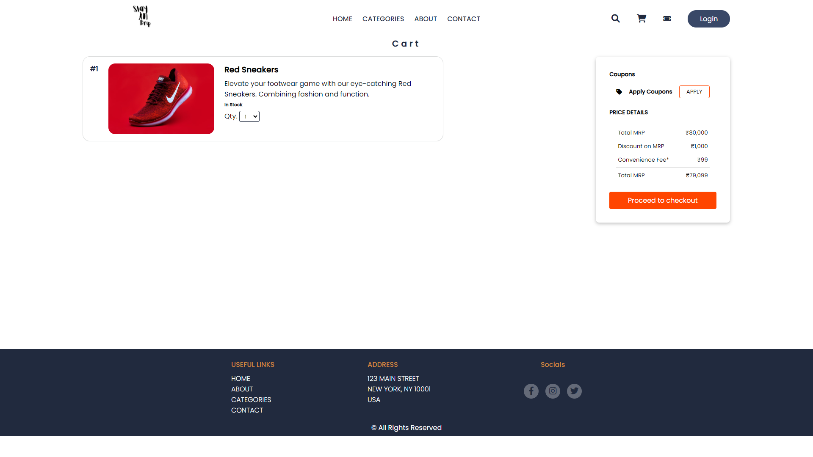

**Checkout Page  
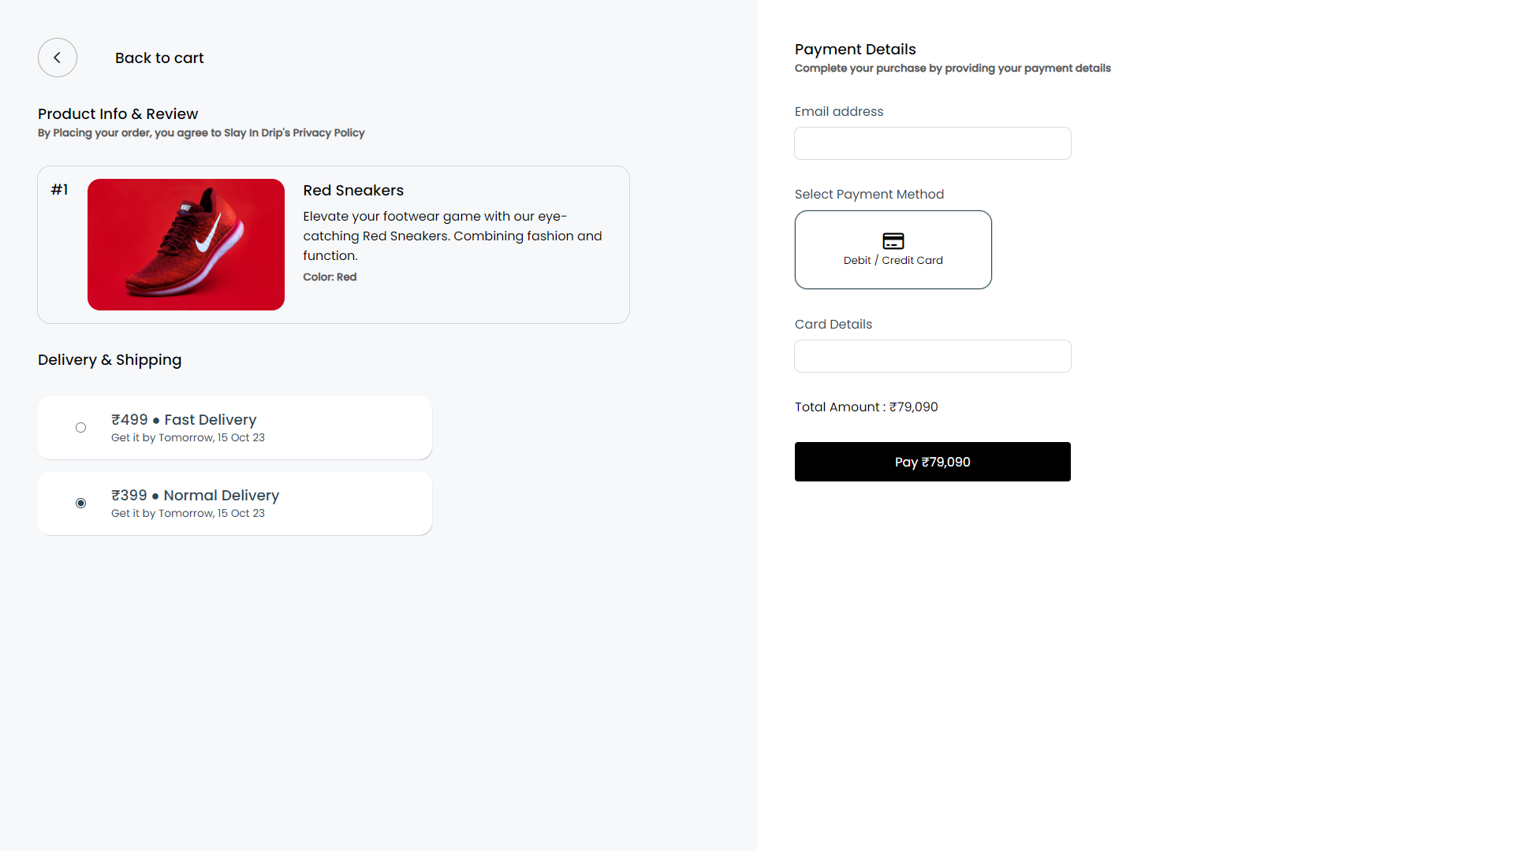**

**Support Page**

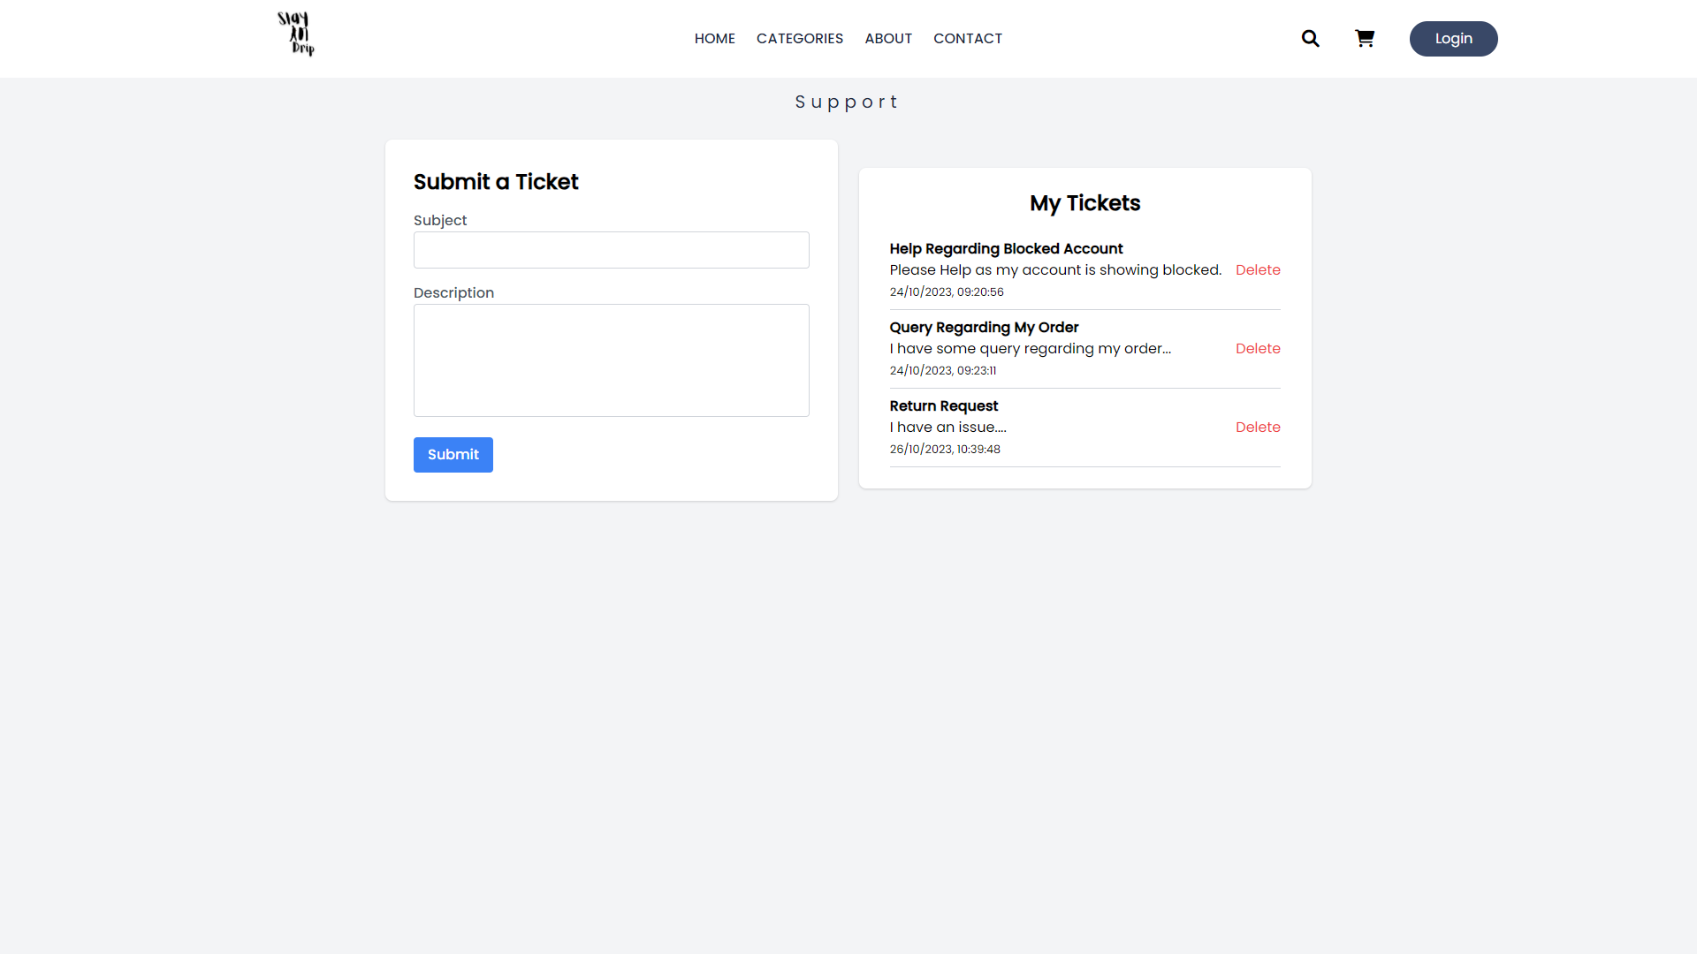

**—---------ThankYou ---------**